Network Connections for Meetinghouse AV Systems
This document is intended for vendor technicians who are upgrading network components in a church meetinghouse. It provides guidance how to ensure the existing AV systems are not disrupted by your work.

Introduction
- AV systems in meetinghouses have a variety of options, depending on the year they were installed and their application in stake centers vs. regular meetinghouses. The equipment listed below includes most of the connections you will find in a building.
- Not all possible conditions can be included in this document. You will likely come across some custom systems or equipment that was added by local church members
- Where members have added AV items beyond meetinghouse standards, please consult with the local FM before disconnecting anything.
- When in doubt, use good judgement and request assistance.
- Prior to starting work, please document all network connections and how it is set up in Church Network Manager (CNM). When finished, ensure all devices are reconnected and networked the same.
- Test the AV systems before leaving the building.

Historical Information
- 2012 and prior systems. Systems installed prior to 2012 likely don’t have any network connections. These systems will not be affected by the network updated.
  - Systems include audio processor manufacturers such as Rane, White, IRP, Ivie and for 2010 may include early BSS models without networked peripherals.
- 2012 to 2018. Systems started including network connections starting in 2012.
  - These connections were likely for the BSS processor and their peripheral controls (Contrio controllers) and the power sequencer.
  - Video equipment with connections was added to stake centers and some meetinghouse.
  - Systems with Iive audio processors don’t need network connections
- 2018 to present. Systems with QSC processor and controls were added to some systems. Network cameras were added.
  - Network connections are critical to QSC systems.
  - Video components
  - Networked PTZ cameras were added in 2022.

Key Components
- Audio processor and its peripherals:
  - Touch panels
  - I/O devices
  - Pulpit up/down controls (in some systems)
  - Peripheral controllers
- Amplifiers
- Video switcher
- HDMI DA
- ListenWIFI (assistive listening)
- Power control and conditioning
- PTZ camera
- TVs
- Member supplied devices

Detailed Information

QSC Systems
Audio systems will not function if QSC components are incorrectly connected or networked. Other than specific amplifiers, all devices are networked.
- Audio Processors (Networked). QSC processors have 2 network connections: Port A is on the Facility Zone, and Port B is on the Public Zone.
  - Core 110f
  - Core 24f
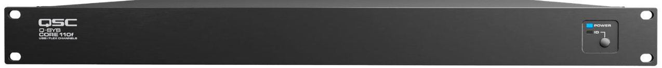
Figure 1QSC Core 110f
- Touch Panels (Networked)
  - TSC-50-G3
  - TSC-55-G2
- I/O (Networked)
  - QIO-GP8X8
- Amplifiers
  - CX-Q 4k8 (networked)
  - CX204V (not networked)
  - MPA-Q Series (not networked)

BSS Systems
- BSS systems with Contrio controllers must be connected to an unmanaged switch.
  - Items connected are the BSS Blu100 and the Contrio controllers
  - Unmanaged switches are typically not connected to a managed switch, but they can be.
  - This is the only instance where the unmanaged switch is maintained.
- Processor
  - Blu-100 (networked with Contrio Controller)
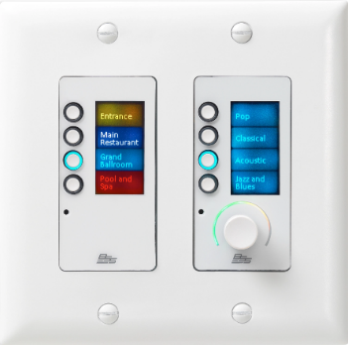
Figure 2 BSS Blu-100
- Controllers –
  - Contrio (networked)
  - Emtech Custom (not networked)

Cameras
Figure 3 BSS Contrio Controller
- Clear Touch RL-400 or RL-500 (Networked)
- Member furnished
  - Members may have furnished their own cameras. If they are connected to the network confirm use with FM. Maintain the connection if in doubt.

Streaming Devices
- Teradek. This is an older streaming device. If it is present in the meetinghouse, confirm whether it is still in use. If it is, then maintain it; otherwise, disconnect it.
- Member furnished
  - Members may have furnished their own steaming devices. If they are connected to the network, confirm with the FM whether they are still in use. When in doubt, maintain the connection.

ListenWIFI
- ListenWIFI servers are connected to the network.
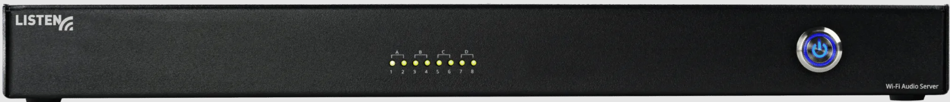
Figure 4 ListenWIFI Server
- Listen or Comtek assistive listening system on 72 MHz band are NOT connected to the network.

